MIRO -

Functionality
A Credit Memo is received from a trade vendor and the Credit Memo is posted with reference to a Purchase Order and serves as a cancellation of the Invoice Receipt. This process will reside under a Finance function.
A credit memo with reference to a purchase order or goods receipt is interpreted by SAP as a cancellation of the invoice receipt.

The term credit memo always refers to a credit memo from the vendor. Therefore, posting a credit memo always leads to a debit posting on the vendor account.

As in the case of invoices, credit memos refer to purchase orders or goods receipts. When you post a credit memo, the total quantity in the purchase order history is reduced by the credit memo quantity. If you do not want the total quantity invoiced to be reduced, you must post the credit memo as a subsequent credit.

Scenario
A vendor made a mistake regarding the quantity to be invoiced and you asked for a credit memo. Now you received a credit memo and you need to post it.

Requirements
Entered vendor invoice you want to post a credit memo for.

Menu Path | Logistics → Materials Management → Logistics Invoice Verification → Document Entry → MIRO - Enter Invoice
Transaction Code | MIRO

1. Double Click on MIRO – Enter Invoice.

Enter Invoice: Company Code 1200

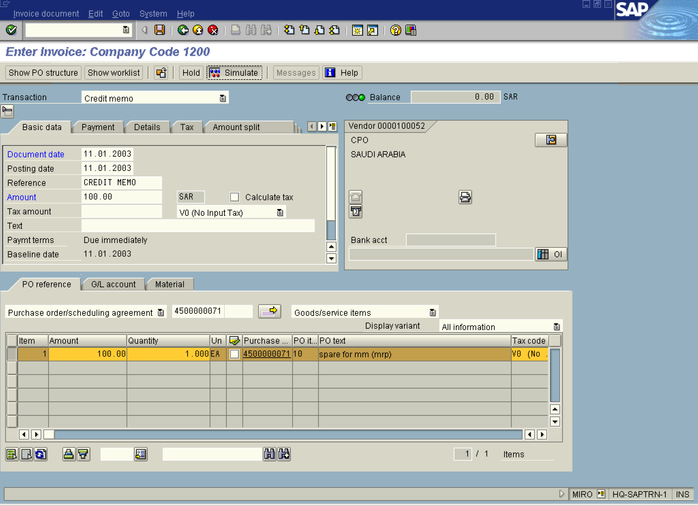

2. Update the following fields:

Field Name | Field Description | Values
Document date | Date the transaction occurred | Example: 110103
Reference | Document description | Example: credit memo
Amount | Amount of the line item | Example: 100
Purchase order/scheduling agreement | Description of the Purchase order/scheduling agreement. | Example: 4500000071

3. Click Enter Button to confirm your entries.

The system lists the order items as per your allocation criteria. In the columns Amount and Quantity, the system suggests the value and quantity invoiced to date for each item. Select the items contained in the credit memo. Check the quantities and amounts suggested by the system and make any necessary corrections.

4. Update the following fields:

Field Name | Field Description | Values
Amount | Amount of the line item | Example: 100

5. Click Enter Button to confirm your entries.

6. Click Simulate Button .

Simulate Document in SAR (Document currency)

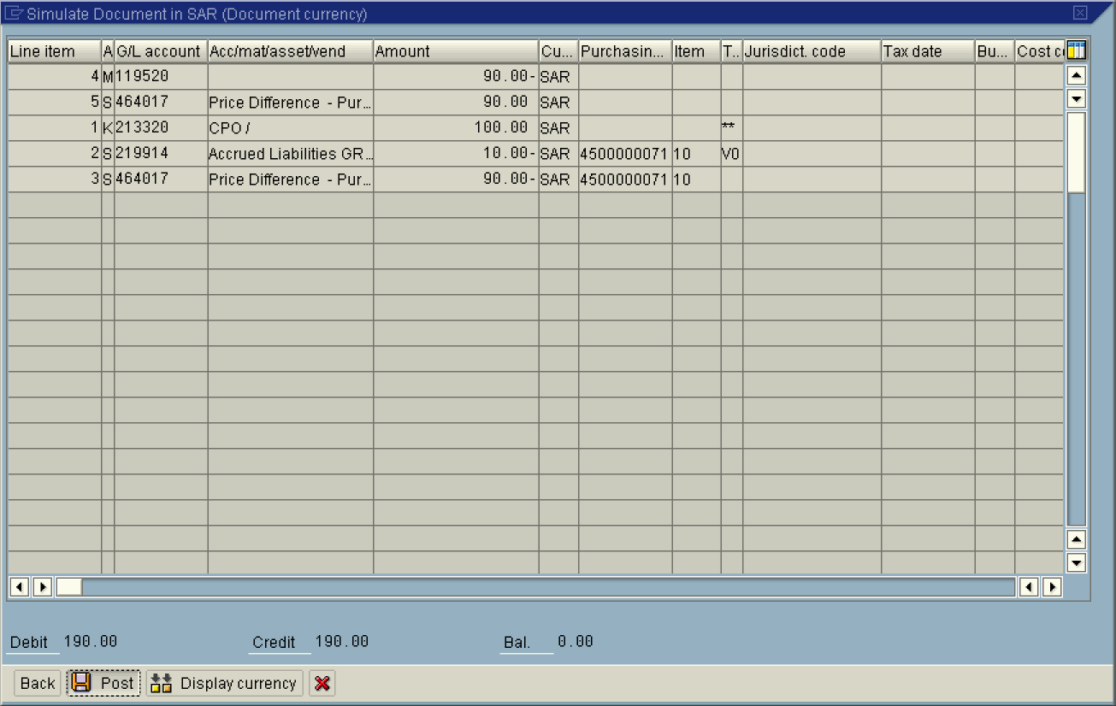

7. Click Post .

8. The message bar displays “Document XXXXXX has been posted in company code 1200” ”

